電通二乙微處理器實驗 實驗結報

實驗名稱 | Lab03-類比輸入
組別 |  | 組員 | 01050852洪維澤

- 實驗目的
使用USB-Serial做輸入輸出
讀取類比輸入脂數值
- 量測0/0.5/1.5/2/2.5之電壓直
- 量測可變電阻之數值
- 量測光敏電阻之數值

- 實驗步驟
1.由Arduino傳送訊息給PC
Arduino傳送一訊息”Heiio,World!”至PC
2.PC經由Serial Monitor接收
打開Arduino IDE的Serial Monitor,確認有收到訊息
3.由PC傳送至Arduino
傳送命令1及0至Arduino
Arduino收到’1’後,LED7亮
Arduino收到’0’後,LED7滅

- 程式碼
(1)
const byte ledPin =12;

void setup()
{
Serial.begin(9600);
Serial.print("Hello,World");
Serial.print("\tLED pin is:");
Serial.print("LedPin");
Serial.print("\nBYE!");

}
void loop(){
byte val;
if(Serial.available())
{
val =Serial.read();
if(val=='1')
{
digitalWrite(ledPin,HIGH);
Serial.println("LED ON");
}
else if(val =='0')
{
digitalWrite(ledPin,LOW);
Serial.println("LED OFF");
}
}
}
- 實驗結果及分析
(2)
void setup() {
Serial.begin(9600);
for (int ledPin = 7; ledPin <= 7; ledPin++) {
pinMode(ledPin, OUTPUT);
}
}
void loop() {
if (Serial.available() > 0) { // 檢查是否有資料可供讀取
int data = Serial.read(); // 讀取進來的 byte
switch (data) { // 根據收到的字元決定要打開哪顆 LED
case '0':
digitalWrite(7, LOW);
Serial.print("7 OFF");
break;
case '1':
digitalWrite(7, HIGH);
Serial.print("7 ON");
break;

default:
for (int thisPin = 2; thisPin <= 6; thisPin++) {
digitalWrite(thisPin, LOW); // 關掉所有的 LED
}
}
}
}
Pc输入 | SerialMonitor
0 |  | 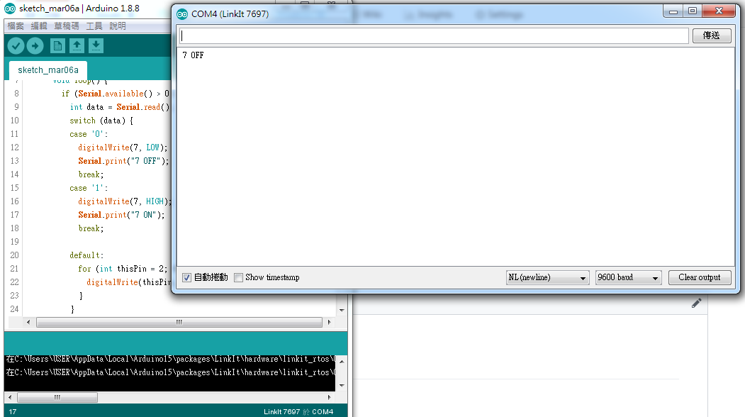
1 |  | 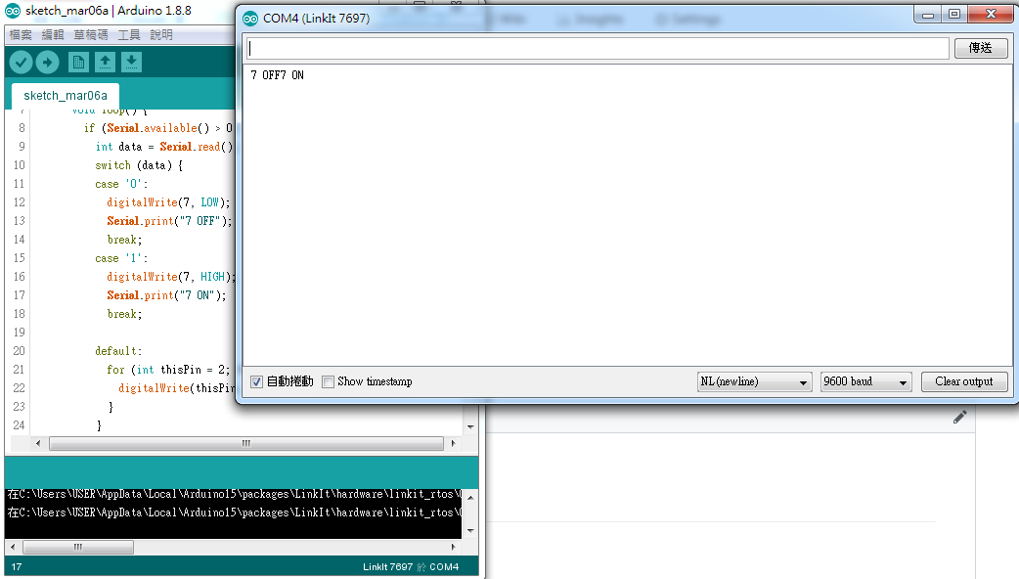

float Analogin = 0;
float k;

void setup(){
Serial.begin(9600);
pinMode(14,INPUT);
}
void loop(){

for (int i=0;i<=5;i++)
Analogin = 0.7* Analogin + 0.3* analogRead(14);

k =(Analogin * 2.5) / 4095;

Serial.println(Analogin);
Serial.println(k);

delay(500);
}
實際電壓(V) | AnalogRead讀值 | 推測電壓(V) | SerialMonitor
2.5 | 3446.98 | 2.5 | 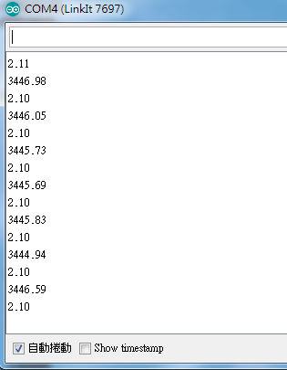
2 | 2601.13 | 2.02 | 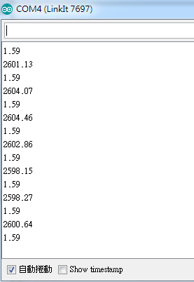
1.5 | 1752.21 | 1.52 | 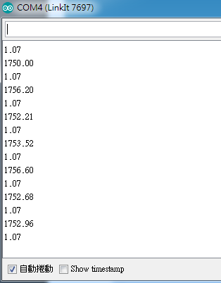
1 | 915.44 | 1.02 | 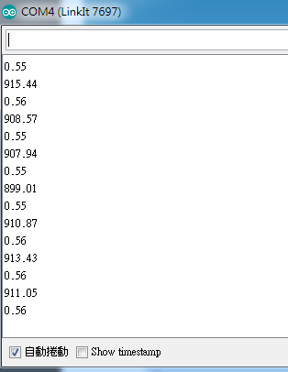
0.5 | 63.94 | 0.51 | 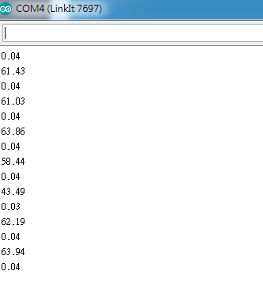
0 | 3.69 | 0 | 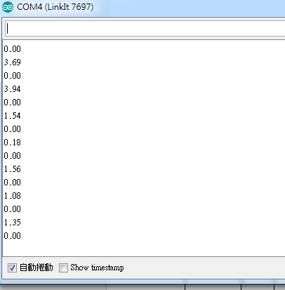
(3)
float sensorValue=0;
float sensorVoltage;
float Vin=2.5;
float R=500000;
float R1;
float R2;
float val;

void setup()
{
Serial.begin(9600);
pinMode(15,INPUT);
}
void loop(){
int i;
for (i=0;i<=5;i++)
sensorValue = 0.7* sensorValue + 0.3* analogRead(15);
sensorVoltage = sensorValue * 2.5 / 4095;
R1 = sensorVoltage * R / Vin;
R2=R-R1;
sensorVoltage= (Vin * R1) / R;
val=analogRead(15);

Serial.print("analogRead=");
Serial.print(val);
Serial.print("\tsensorVoltage=");
Serial.print(sensorVoltage );
Serial.print("\tR=");
Serial.print(R);
Serial.print("\tR1=");
Serial.print(R1);
Serial.print("\tR2=");
Serial.println(R2);

delay(500);
}
電阻KΩ | AnalogRea | 電壓 | 電阻 | SerialMonitor
20.1 |  | 0.5 | 10.2 | 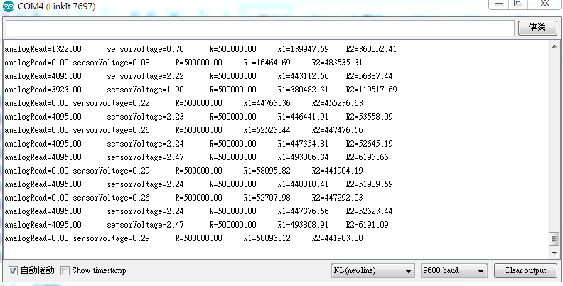
62.8 |  | 0.8 | 45.8 | 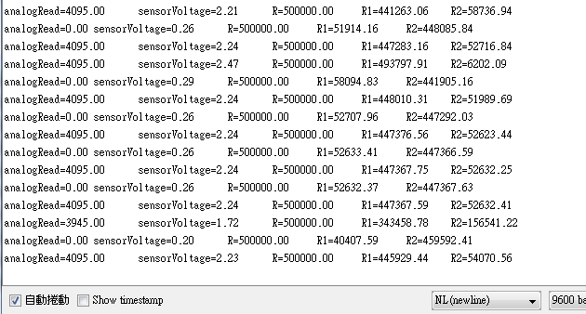
80.2 | 761 | 0.47 | 93．87 | 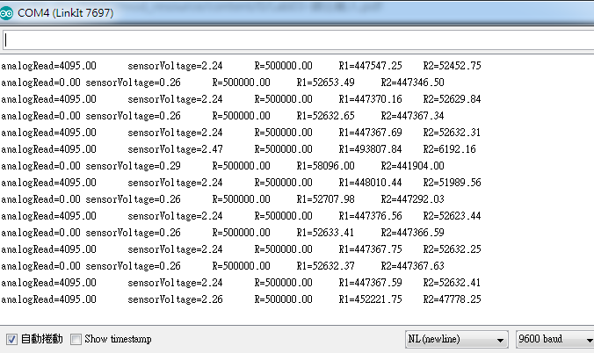

(4)
float sensorValue=0;
float sensorVoltage;
float R=5000000;
float R1;
float val;

void setup()
{
Serial.begin(9600);
pinMode(15,OUTPUT);
}
void loop(){
int i;
for (i=0;i<=5;i++)
sensorValue = 0.7* sensorValue + 0.3* analogRead(15);
sensorVoltage = sensorValue * 2.5 / 4095;
R1 = sensorVoltage * R / 2.5;
val=analogRead(15);

Serial.print("analogRead=");
Serial.print(val);
Serial.print("\tsensorVoltage=");
Serial.print(sensorVoltage );
Serial.print("\tR1=");
Serial.println(R1);

delay(500);
}

- 心得討論
這禮拜的作業十分複雜，第4個怎麼都弄不出來。
- 修正電路圖

